# Why Is My Charger Hot?

A common issue in our day-to-day cycle is “Why is my charger hot!” Generally, this is something not too alarming but also ensures inconvenience while working with a device. The occurrence takes place due to unparallel plugins, malfunctioned adapters, outlets, and many more we are to discuss in the next portion.

## The explanation for why the charger is sizzling

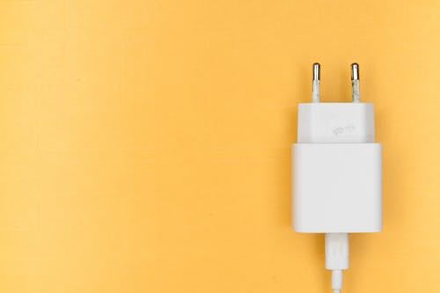

It is a convention to use the pair-up charger that comes with your device. There can be tons of fact that makes your charger go high. But do keep this in mind to go for the chargers attached with the device. The coming section emphasizes the major problems.

### Using low-graded charger

A huge collection of chargers is loaded in the store, from different unknown companies. Not each of them manufactures quality and effective ones.

Supposedly, you need a specific power ranged charger but the unknown new charger is unable to meet the requirements, then you know this can cause you problem. However, it is recommended to choose from quality brands and thus you can save yourself from the mess.

### Wrong chargers

Often this might seem that a charger is fully connected to the port but it is yet to turn the adapter and phone hot. Now, what can be the reason? Specific devices require specific electronic components to convert the suitable power. And if there is disbalance then you know the loss of energy rises and makes the charger hot.

### Power loss

In the usual case, it is normal for your charger to heat up. The power that the outlet provides is AC and the device takes DC. So, the conversion produces some electrical power loss that causes the heat to rise. If the range is below 50 degrees Celsius then it’s natural and nothing to panic about.

### Outlet problem

The plugging outlet can show disturbance, though the possibility is very low. Not usually do we see a problem in sockets. But if you run into a new place with poor management, your charger might not receive proper electrons, and thus make it hotter.

### Port pins death

A common problem having abrupted inner port pins. Most of us do not maintain soft gentle plugins rather join in a hurry or detach from port very unconsciously. This might damage the port line and can lead to normal power transfer. Consequently, you might get slow charging as well as heated chargers.

### Weak shields and damaged wire

Long used wire and chargers can have loosened connections. The result shows minor shocks from the shield and spikes. Also, the important thing to be noticed is the power loss on large scale and the charger easily gets revved up.

You might think it is running well and nice but this unconventional connectivity will go towards battery life reduction. Not to mention due to power loss your adapter and charger can die soon.

### Dirt and debris

A very minor issue is dirt. isn’t it? No, it is not if it’s an electronic gadget and this can make you go round for so long that you won’t be able to figure out the issue. Often the port needs a cleaning. The microparticles of dirt and nearly invisible substances clog the port.

However, the proper transmission gets blocked and the excessive heat is drawn out as a by-product. Simply take a cotton pad or buds with a little alcohol and rub the ports and you might see a difference.

## Is it normal for a charger to get hot

For the minimal power loss every charger ends emit wave of heats. But the usual threshold is below 122 Fahrenheit and if your charger has some unusual burning instinct then the situation is not normal. In this case you better switch to a preferable adapter, more precisely get yourself a new one.

## Why is my iPhone charger hot and not charging

iPhone charger aka lightning has complaint being chargers with weak shields. That is also not an issue, but the charger getting hot is undefined when you have a seeming new one. However, unplug the charger, correct the connection of the port and the outlet and check once again.

### iPhone 11 charger gets hot

Every specific gadget needs its own appliances to run swiftly, and same goes for this case. You simply cannot expect a Prior versioned gadget charger to use in iPhone 11 and the updated version might also not work. There is high chance of entropy imbalance as specified gadgets require individual level of power.

## Solving charger lacking is not of help

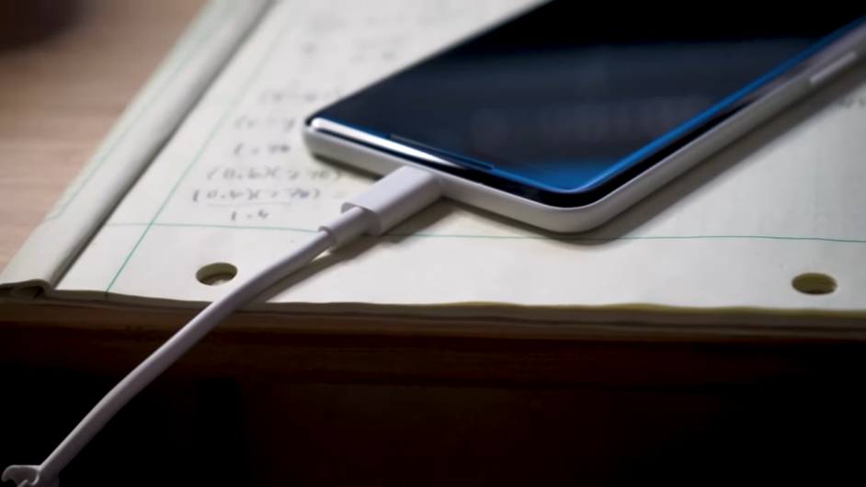

All those methods to clear out the pathway are not helping? It is obvious that the charger getting hot is not always a charger to be blamed for. You can check our device and give it a treatment. Often the charger is getting hot for a malfunctioned device.

## A changed adapter might not work

It is not unusual to use one adapter or charger head for multiple devices, but some devices do require an extra boost, and some need slow pace energy. In that case, you can get slow charging and a hot charger accordingly.

## FAQ

Does high amperage have anything to do with the charger getting hot?

Apparently, yes. In this case, the AC to DC conversion takes a load and thus emits energy on a large scale. The hotness you feel is the reduced energy after conversion.

Should I change my charger if it’s unusually hot?

This is a good idea to change the charger and see if this makes any difference. Also, it doesn’t make any difference you know the problem is in the device circuits. And unusual hot chargers can lead to worse incidents often, so it’s recommended to have a changed one.

## Conclusion

Electrical mismanagement and malware can cause a massive mess if not checked and taken under consideration within time. It is recommended not to use a phone laptop while charging else the charger get hot. Chargers that are often showing problems and have broken lines need to be altered so you can have a safe environment around you.